In the next lecture Colt covers how to use Google Fonts in your project. The interface for Google Fonts has changed since he made this video so I'll be including updated instructions on how to use the new version, below:

* Navigate to <https://fonts.google.com/>
* Use the search bar in the top right corner to find the font of your choosing (or simply browse the directory for a font)
* 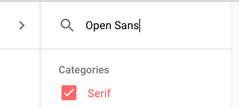
* Click the red circle with the plus sign to the right of the font name
* 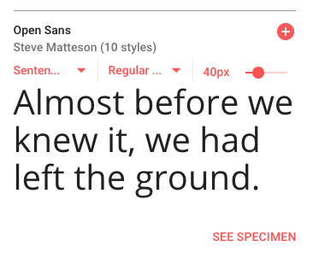
* Now click the grey tab that appears in the lower right corner of the screen
* https://udemy-images.s3.amazonaws.com/redactor/2017-03-07_21-05-34-0dbb46144b785d7682f842b6e3ef329c/Screen%20Shot%202017-03-07%20at%203.04.57%20PM.png
* Click the "customize" tab and select any of the options you need
* 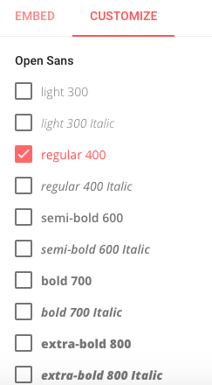
* Click the "embed" tab and copy the link beneath the "standard" option
* 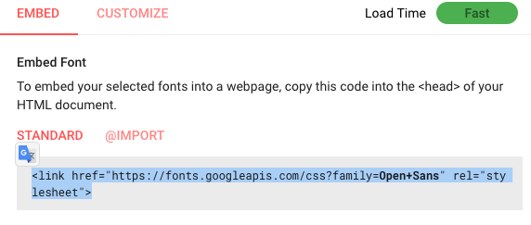
* Paste this link tag into the <head>  of your project, before the link to your custom CSS

-----------------------------------

You're all set! Feel free to post a question in the Q&A if you have any trouble getting this working in your project :)

BOX model

